Deltoidal Icositetrahedron

Definition
# Source: AI Source: Provided by: [Data Path: Persons Table -> ID Column: 1, Name_En Column: Motasem Essam] -> From: [ChatGPT] on [7/25/2026]
A Deltoidal Icositetrahedron is a convex polyhedron belonging to the Catalan solids. It has 24 congruent kite-shaped faces, 48 edges, and 26 vertices.
It is also known as the Trapezoidal Icositetrahedron.
It is the dual polyhedron of the Rhombicuboctahedron, an Archimedean solid.
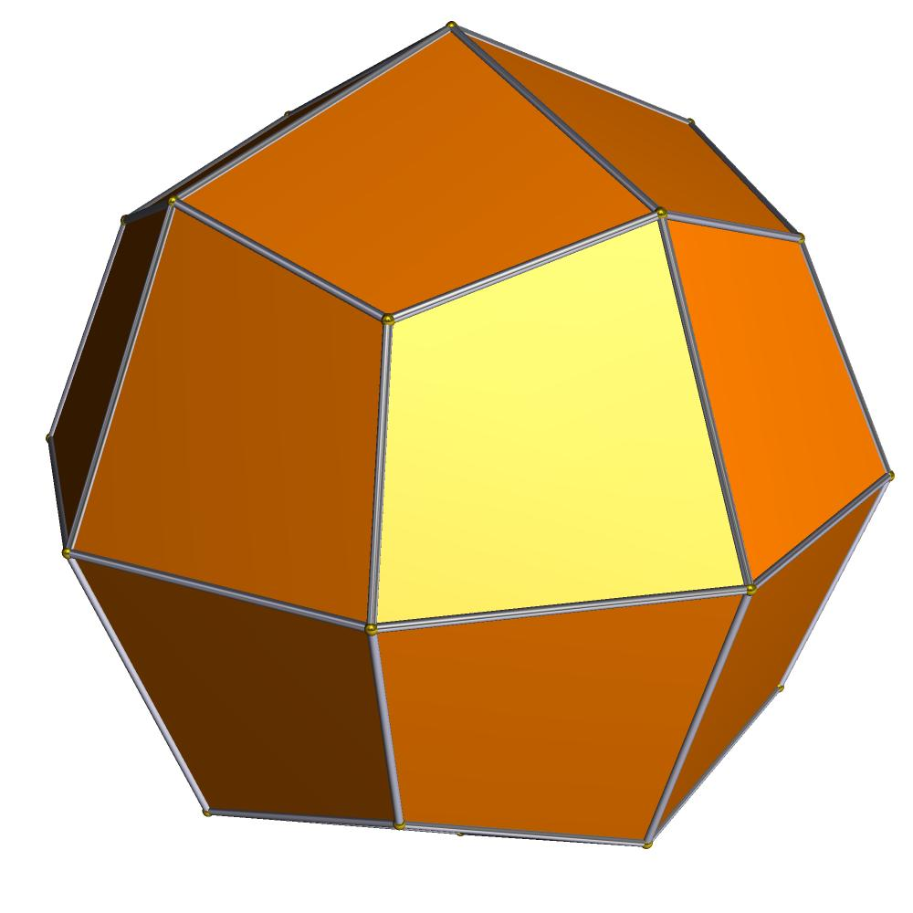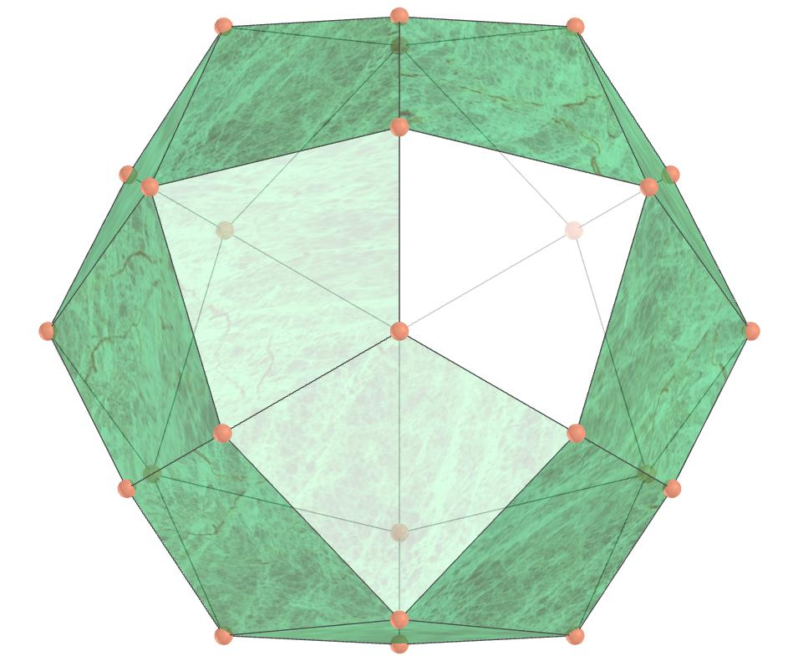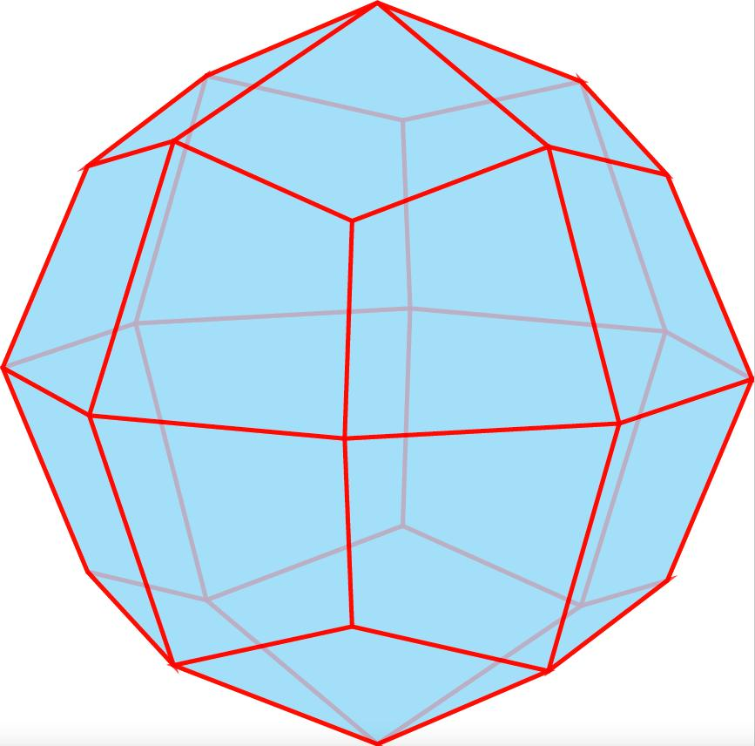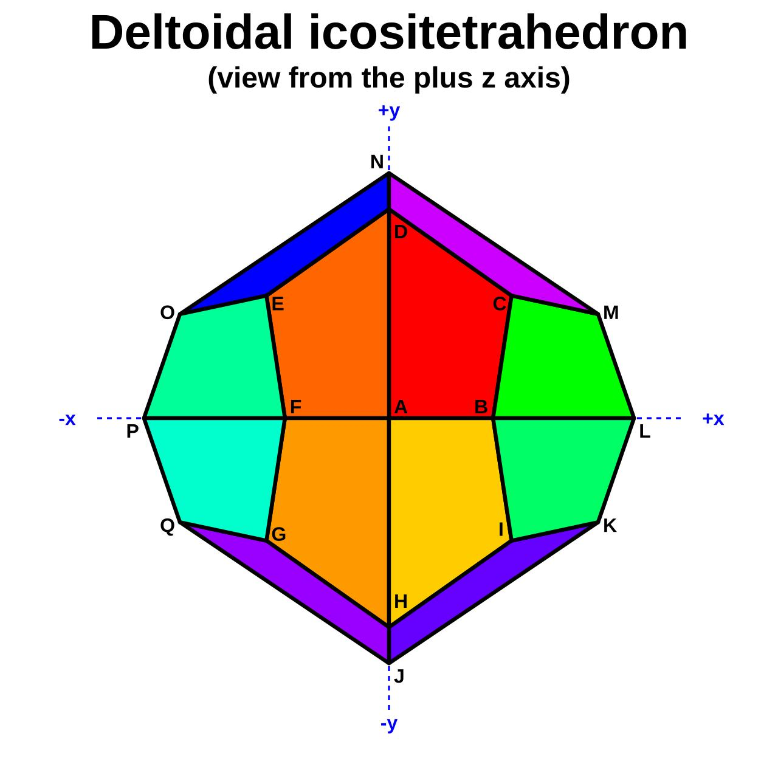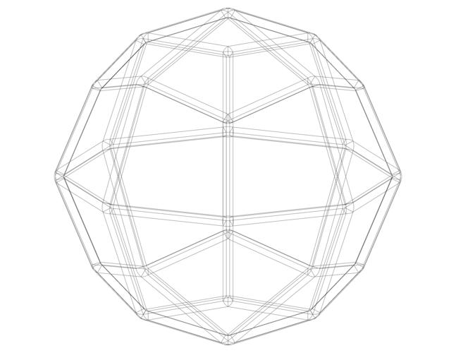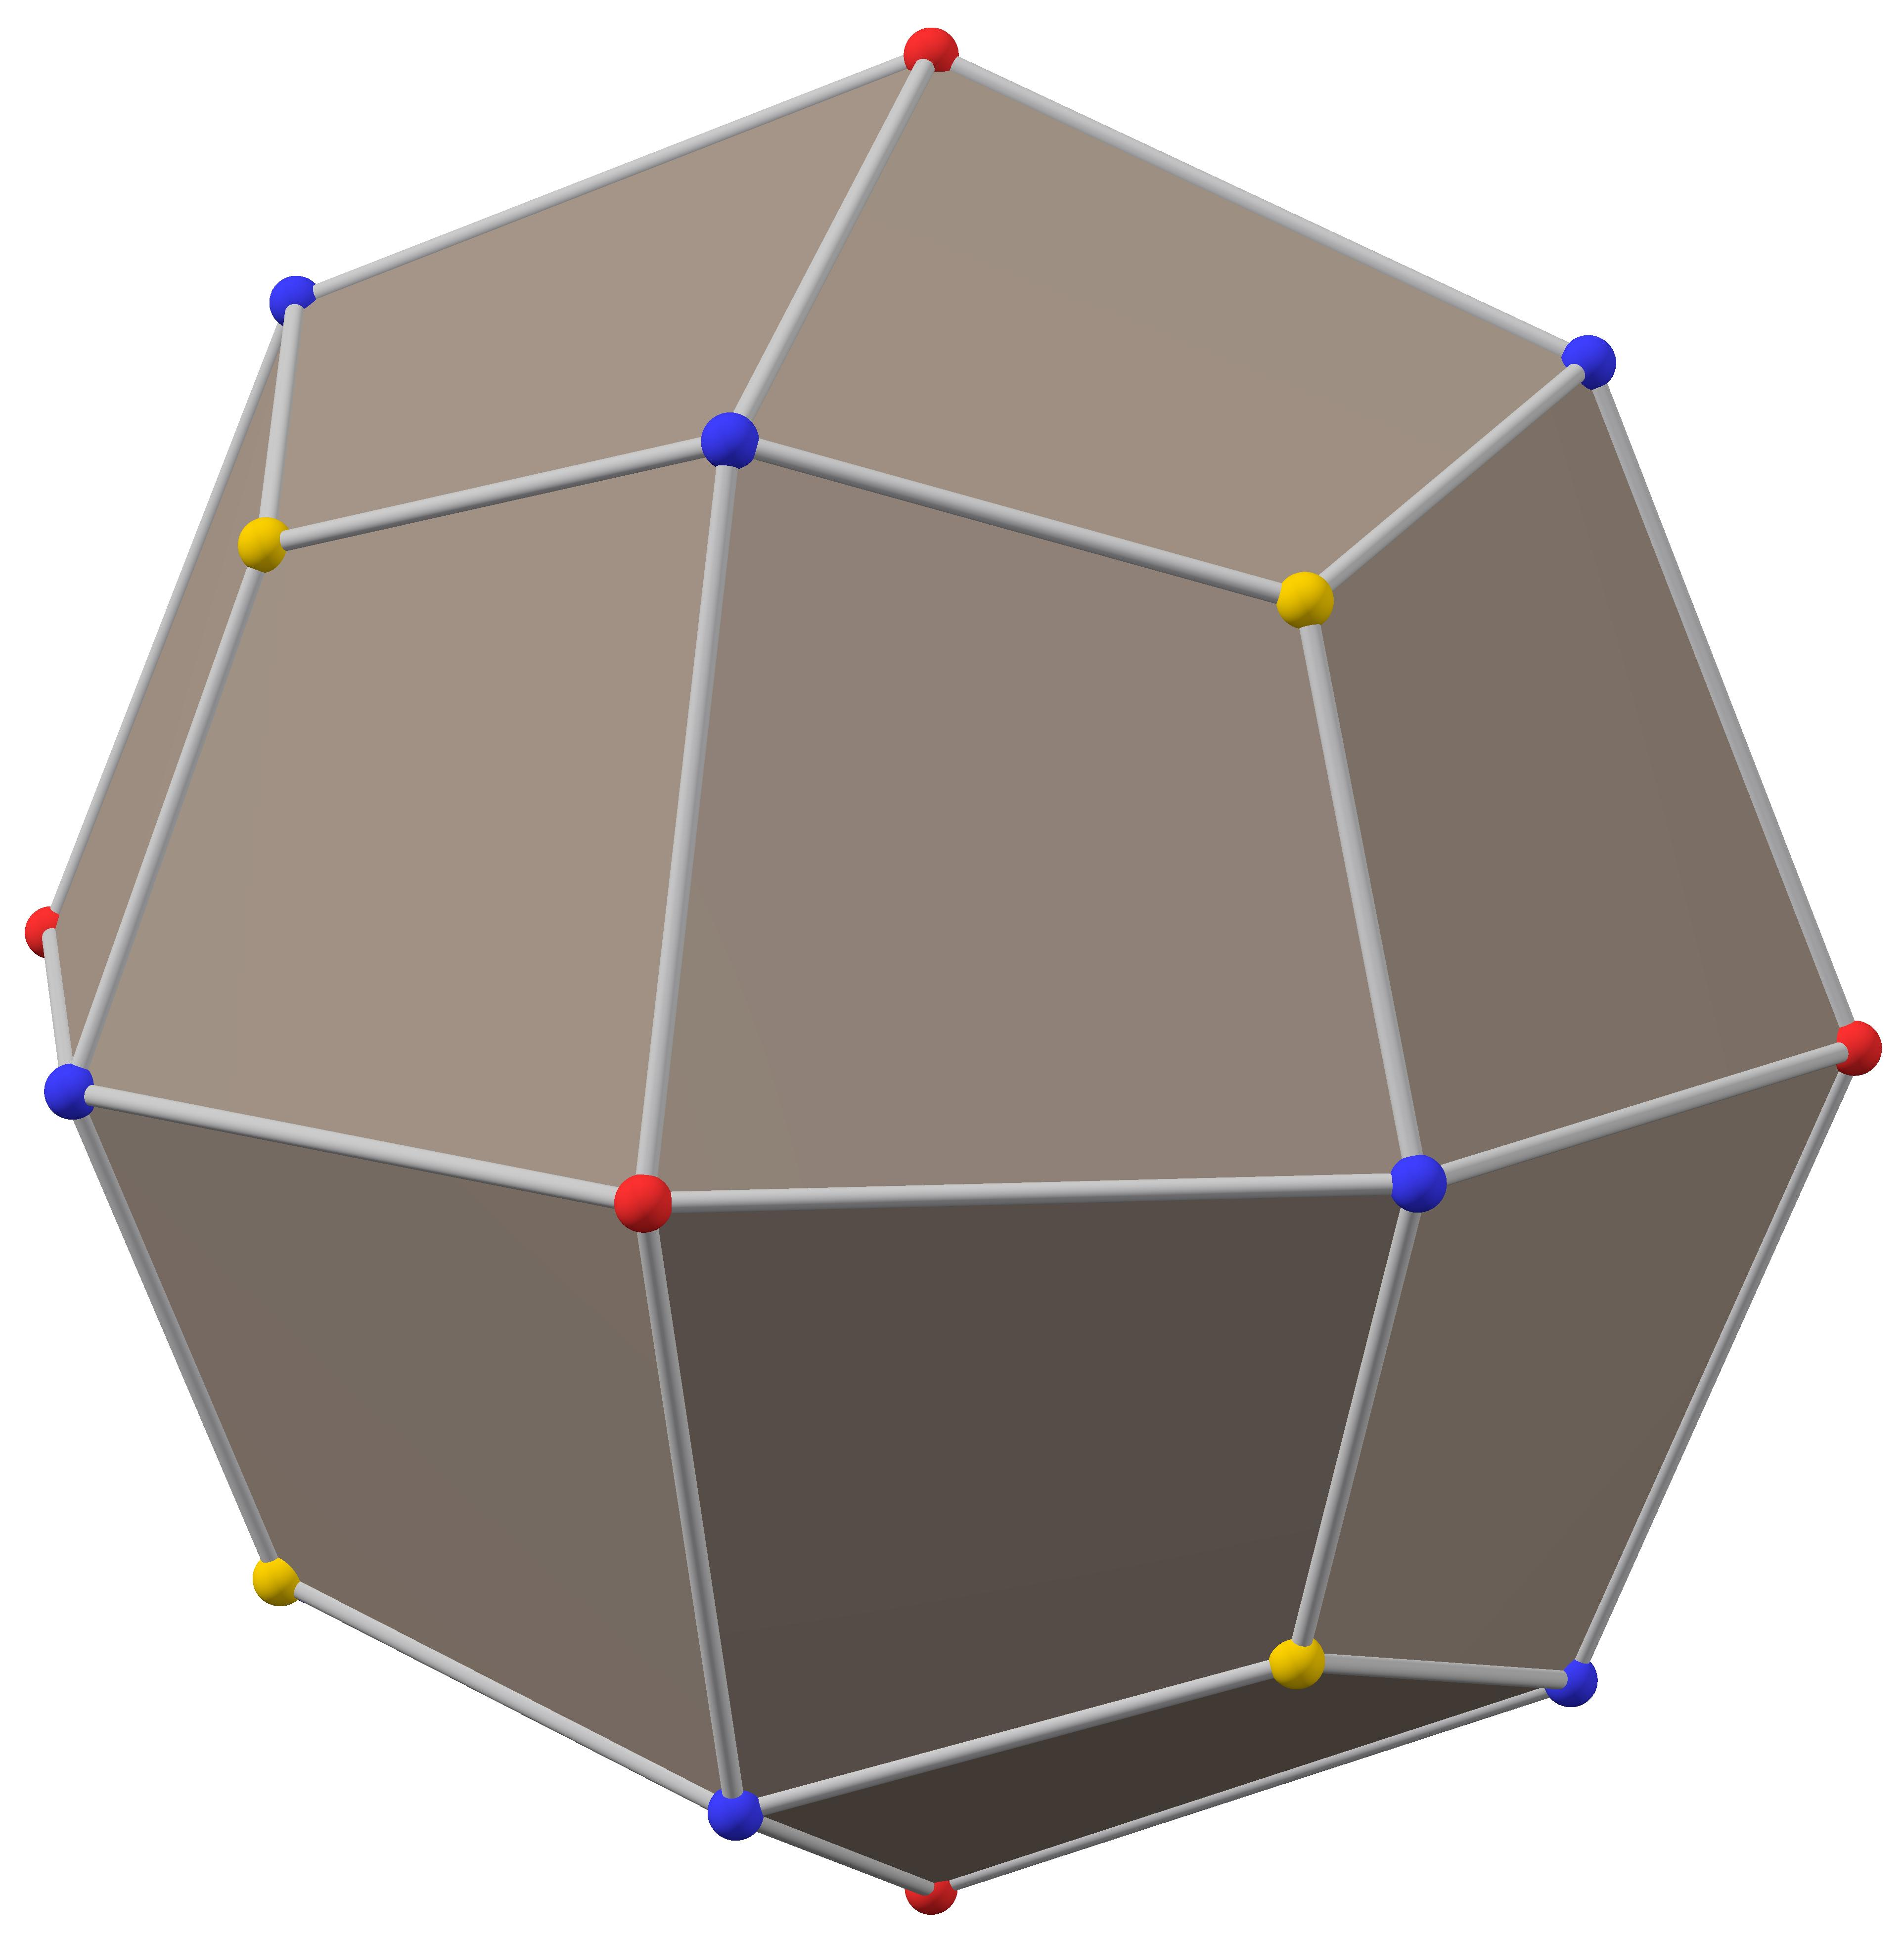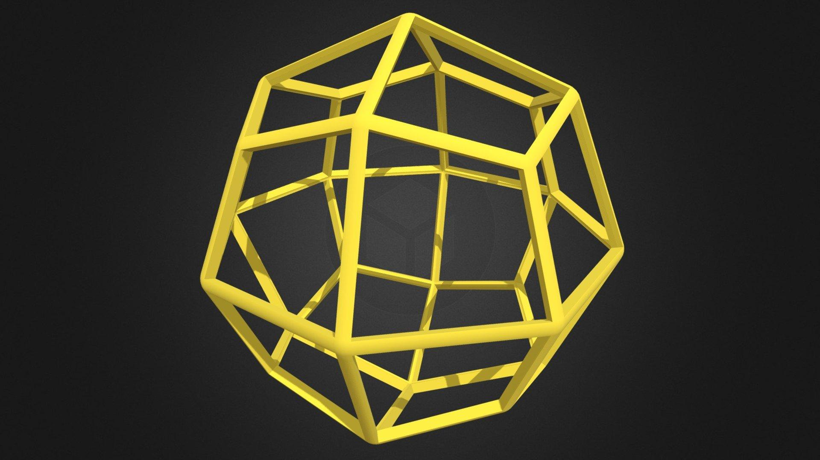

Simple Definition
# Source: AI Source: Provided by: [Data Path: Persons Table -> ID Column: 1, Name_En Column: Motasem Essam] -> From: [ChatGPT] on [7/25/2026]
A Deltoidal Icositetrahedron is a three-dimensional geometric solid with 24 identical kite-shaped faces arranged symmetrically around its center.

Geometric Structure
# Source: AI Source: Provided by: [Data Path: Persons Table -> ID Column: 1, Name_En Column: Motasem Essam] -> From: [ChatGPT] on [7/25/2026]
The Deltoidal Icositetrahedron has the following main components:
- 24 congruent kite-shaped faces: Each face is a quadrilateral with two pairs of adjacent equal sides.
- 48 edges: There are two different edge lengths.
- 26 vertices: The vertices form three different groups according to how many faces meet there.
- Octahedral symmetry: Its overall shape has the symmetry of a cube and an octahedron.
The faces are congruent kites, but they are not regular polygons.

Face Structure
# Source: AI Source: Provided by: [Data Path: Persons Table -> ID Column: 1, Name_En Column: Motasem Essam] -> From: [ChatGPT] on [7/25/2026]
The Deltoidal Icositetrahedron consists of 24 kite-shaped faces.
Each kite has:
- Four sides.
- Two pairs of adjacent equal-length sides.
- Three equal acute angles.
- One larger obtuse angle.
Approximate interior angles of each face are:
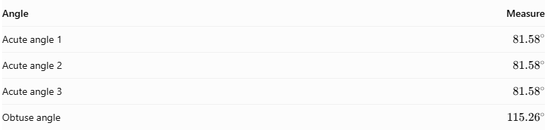
Angle | Measure
Acute angle 1 | $${81.58}^{°}$$
Acute angle 2 | $${81.58}^{°}$$
Acute angle 3 | $${81.58}^{°}$$
Obtuse angle | $${115.26}^{°}$$
The angles add up to ${360}^{°}$, as expected for a quadrilateral.

Edge Structure
# Source: AI Source: Provided by: [Data Path: Persons Table -> ID Column: 1, Name_En Column: Motasem Essam] -> From: [ChatGPT] on [7/25/2026]
The solid has 48 edges, divided into two length categories:
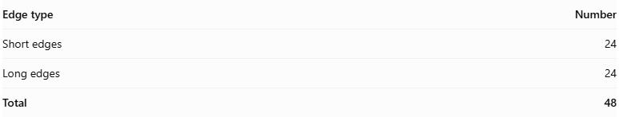
Edge type | Number
Short edges | 24
Long edges | 24
Total | 48
Each kite face has two short edges and two long edges, arranged alternately around its boundary.
The ratio of long-edge length to short-edge length is:
$$\frac{L}{S}=\frac{4+\sqrt{2}}{7}$$
Correction: this expression gives the short-to-long ratio. Therefore:
$$\boxed{\frac{L}{S}=\frac{7}{4+\sqrt{2}}}$$
Approximately:
$$\frac{L}{S}≈1.293$$

Vertex Structure
# Source: AI Source: Provided by: [Data Path: Persons Table -> ID Column: 1, Name_En Column: Motasem Essam] -> From: [ChatGPT] on [7/25/2026]
The Deltoidal Icositetrahedron has 26 vertices, divided into three groups:

Vertex group | Number | Faces meeting
First group | 8 | 3
Second group | 6 | 4
Third group | 12 | 4
Total | 26
More specifically:
- 8 vertices are connected by three short edges.
- 6 vertices are connected by four long edges.
- 12 vertices are connected by alternating short and long edges.
Thus, eight vertices have three kite faces meeting at each vertex, while the remaining eighteen have four kite faces meeting at each vertex.

Mathematical Properties
# Source: AI Source: Provided by: [Data Path: Persons Table -> ID Column: 1, Name_En Column: Motasem Essam] -> From: [ChatGPT] on [7/25/2026]
Geometric data
24
Faces
48
Edges
26
Vertices
Euler's formula:
$$V-E+F=2$$
$$26-48+24=2$$
Verified
The solid is convex and face-transitive, meaning that all 24 faces are geometrically equivalent and can be mapped onto one another by its symmetries.

Symmetry
# Source: AI Source: Provided by: [Data Path: Persons Table -> ID Column: 1, Name_En Column: Motasem Essam] -> From: [ChatGPT] on [7/25/2026]
The Deltoidal Icositetrahedron has full octahedral symmetry.
Its symmetry properties include:
- Fourfold rotational symmetry around three mutually perpendicular axes.
- Threefold rotational symmetry around four body-diagonal axes.
- Twofold rotational symmetry around six additional axes.
- Reflection symmetries.
- Central inversion symmetry.
Its full symmetry group is denoted:
$$\boxed{O_{h}}$$
This is the same overall symmetry group as a cube and an octahedron.

Dual Polyhedron – Rhombicuboctahedron
# Source: AI Source: Provided by: [Data Path: Persons Table -> ID Column: 1, Name_En Column: Motasem Essam] -> From: [ChatGPT] on [7/25/2026]
The dual of the Deltoidal Icositetrahedron is the Rhombicuboctahedron.
The dual relationship means:
- Each kite face corresponds to one vertex of the rhombicuboctahedron.
- Each vertex of the Deltoidal Icositetrahedron corresponds to one face of the rhombicuboctahedron.
- Each edge corresponds to an edge in the dual solid.
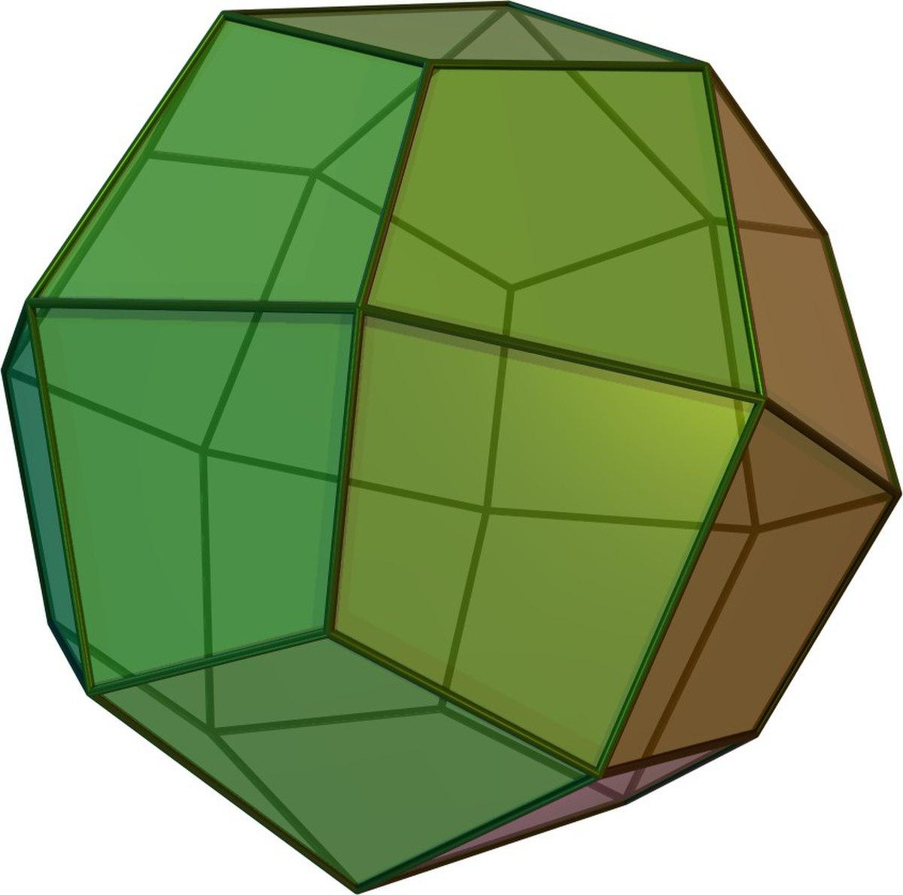
Deltoidal Icositetrahedron
24 faces, 48 edges, 26 vertices
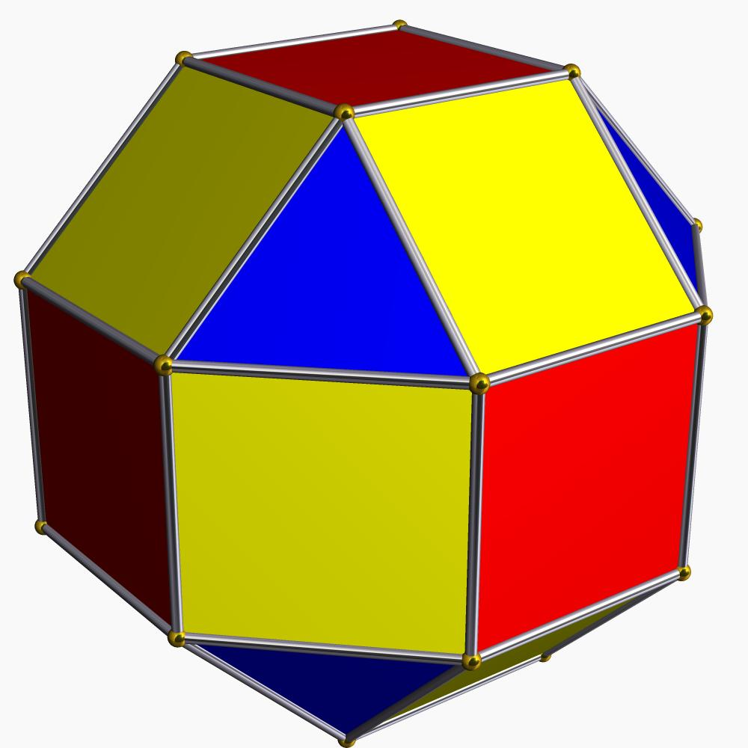
Rhombicuboctahedron
26 faces, 48 edges, 24 vertices

Surface Area and Volume
# Source: AI Source: Provided by: [Data Path: Persons Table -> ID Column: 1, Name_En Column: Motasem Essam] -> From: [ChatGPT] on [7/25/2026]
The surface area is the sum of the areas of its 24 congruent kite-shaped faces:
$$\boxed{SA=24A_{k}}$$
Where $A_{k}$ is the area of one kite.
The area of a kite can be calculated using its diagonals:
$$A_{k}=\frac{1}{2}d_{1}d_{2}$$
Therefore:
$$\boxed{SA=12d_{1}d_{2}}$$
The volume depends on the overall dimensions of the solid. For a standard model with unit edge length on the dual rhombicuboctahedron, its volume is:
$$V=\frac{16(1+2\sqrt{2})}{7}$$
$$\boxed{V≈8.751}$$

Relationship to Other Solids
# Source: AI Source: Provided by: [Data Path: Persons Table -> ID Column: 1, Name_En Column: Motasem Essam] -> From: [ChatGPT] on [7/25/2026]
The Deltoidal Icositetrahedron belongs to the family of Catalan solids.
Other examples include:
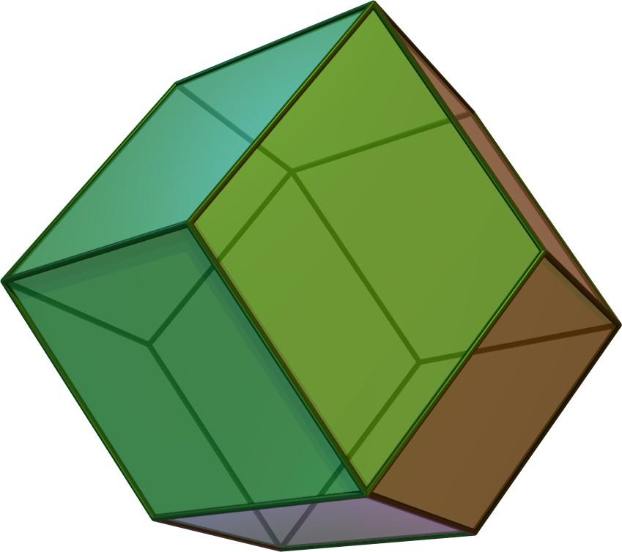
Rhombic Dodecahedron
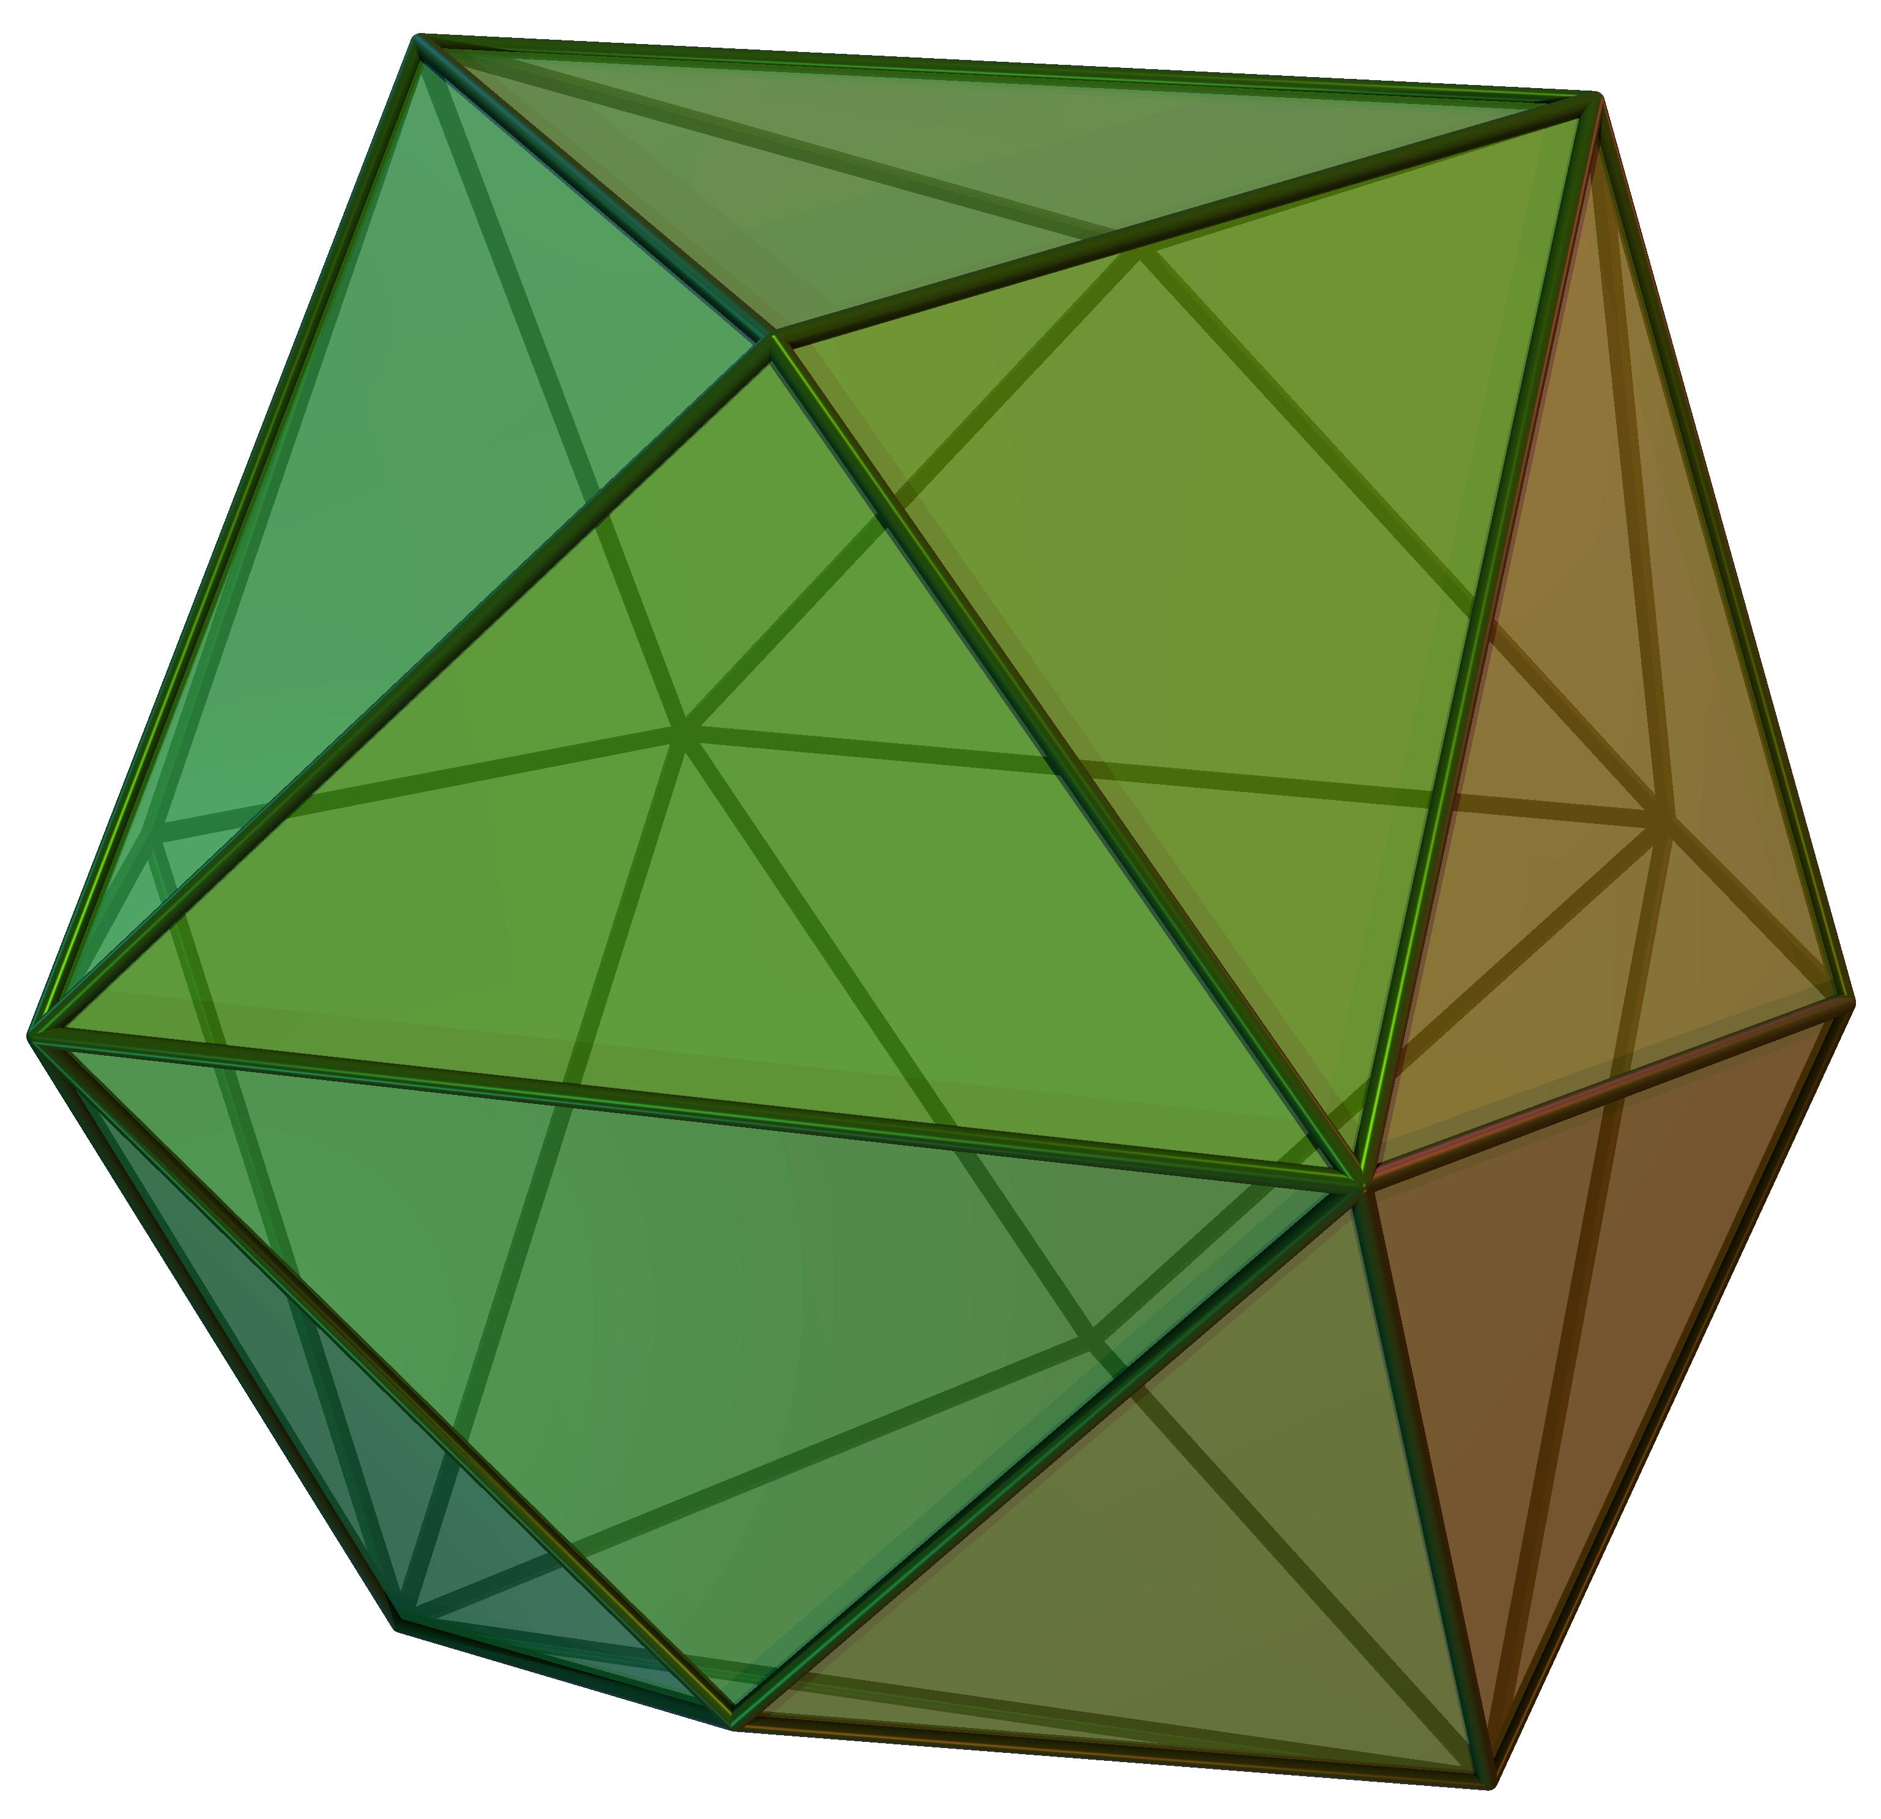
Tetrakis Hexahedron
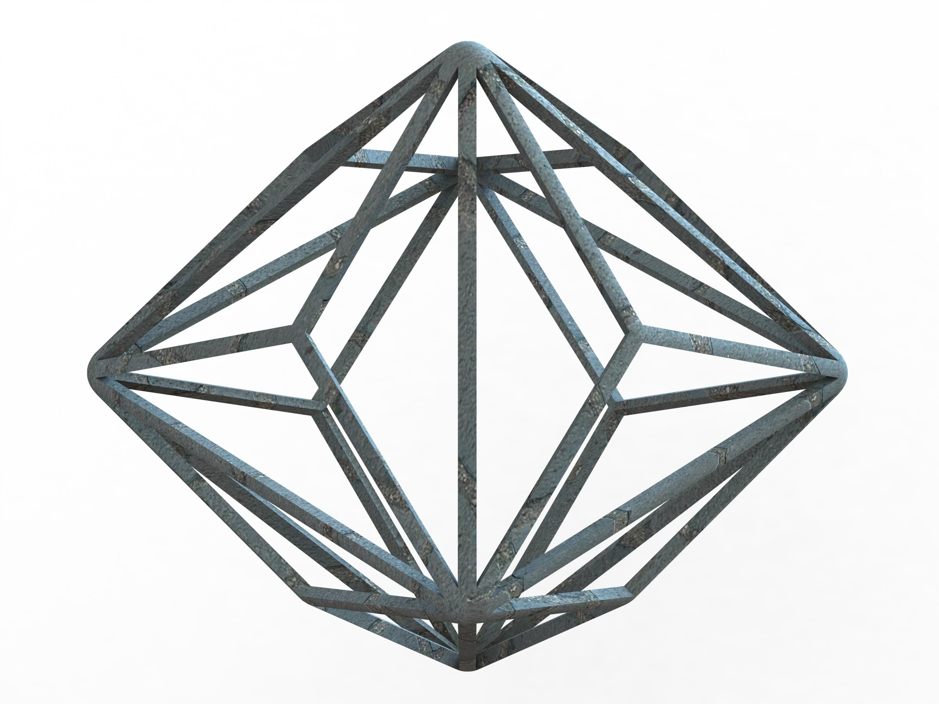
Triakis Octahedron
Deltoidal Icositetrahedron
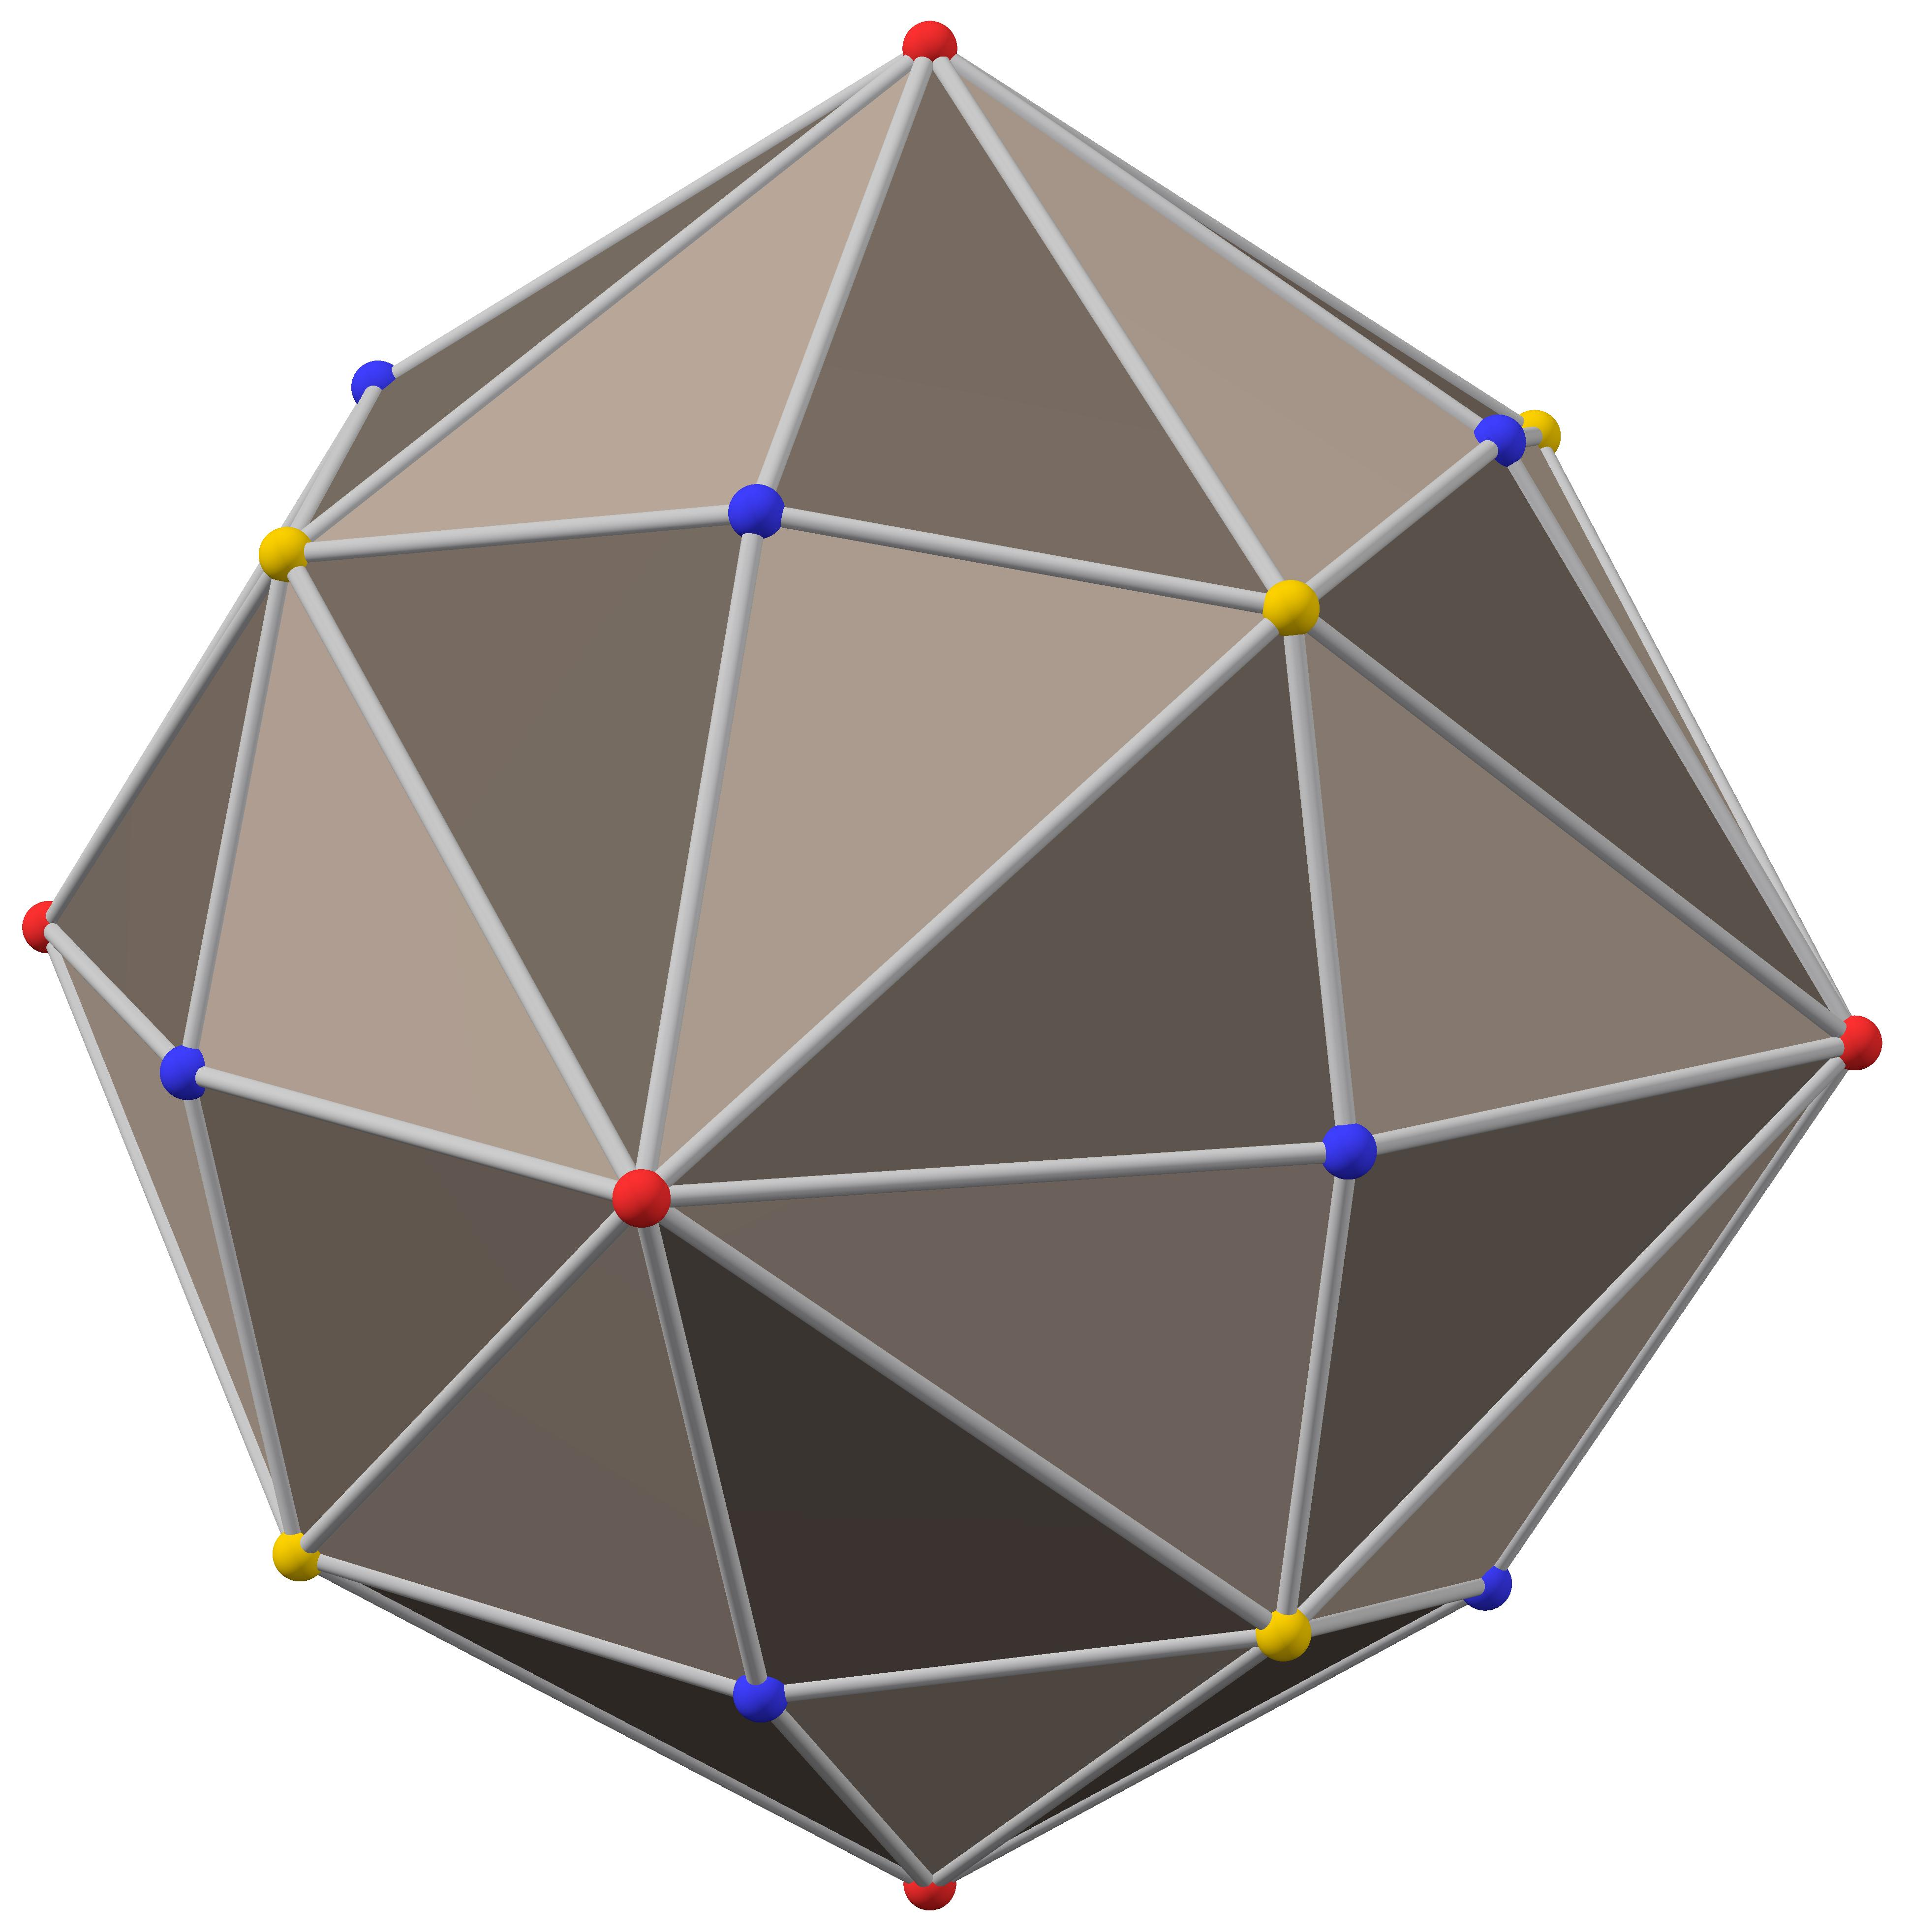
Disdyakis Dodecahedron
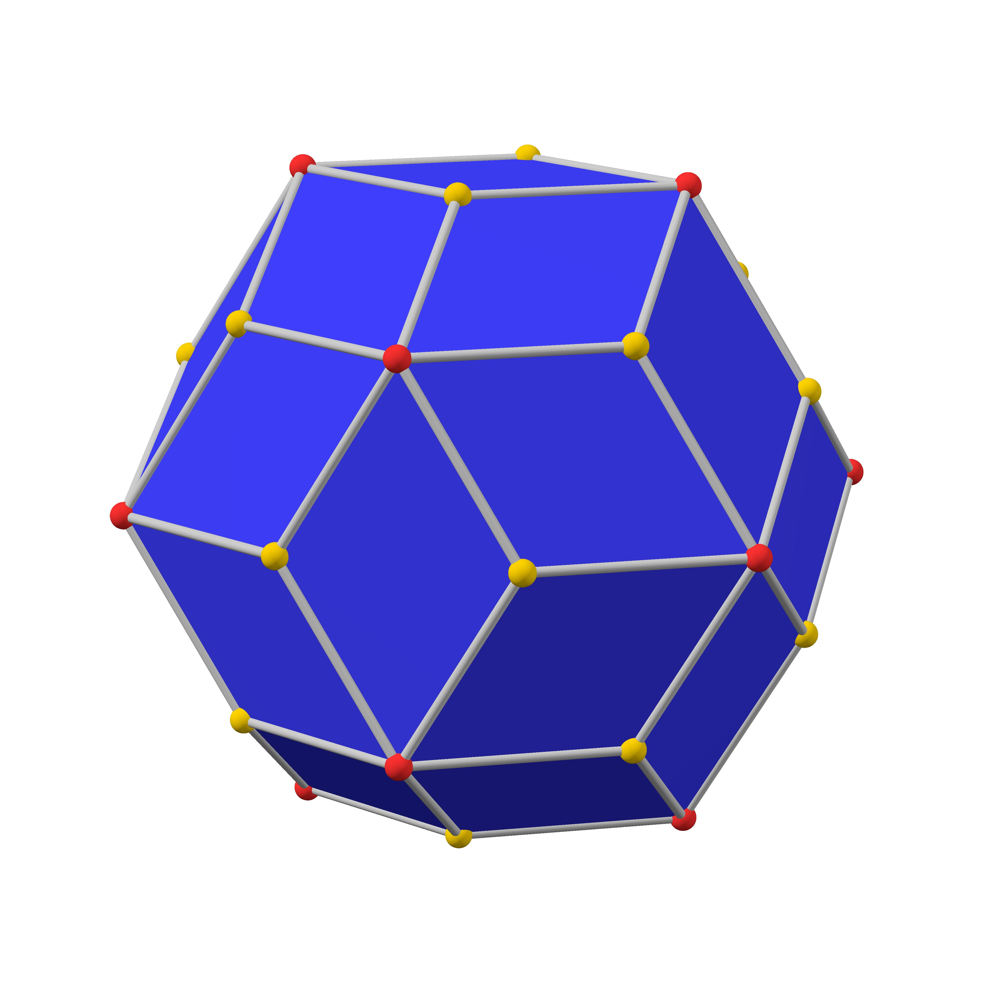
Rhombic Triacontahedron

Construction of a Deltoidal Icositetrahedron

Geometric Instruments Used
# Source: AI Source: Provided by: [Data Path: Persons Table -> ID Column: 1, Name_En Column: Motasem Essam] -> From: [ChatGPT] on [7/25/2026]
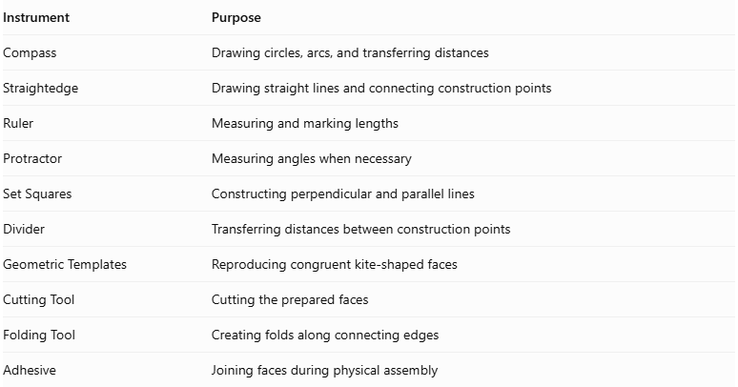
Instrument | Purpose
Compass | Drawing circles, arcs, and transferring distances
Straightedge | Drawing straight lines and connecting construction points
Ruler | Measuring and marking lengths
Protractor | Measuring angles when necessary
Set Squares | Constructing perpendicular and parallel lines
Divider | Transferring distances between construction points
Geometric Templates | Reproducing congruent kite-shaped faces
Cutting Tool | Cutting the prepared faces
Folding Tool | Creating folds along connecting edges
Adhesive | Joining faces during physical assembly

Instrument-Based Construction Procedures

Step 1: Construct the Reference Polyhedron
# Source: AI Source: Provided by: [Data Path: Persons Table -> ID Column: 1, Name_En Column: Motasem Essam] -> From: [ChatGPT] on [7/25/2026]
Use the Rhombicuboctahedron as the reference solid because the Deltoidal Icositetrahedron is its dual.
- Construct or obtain an accurate geometric model of the Rhombicuboctahedron.
- Identify its 8 equilateral triangular faces.
- Identify its 18 square faces.
- Verify its 26 faces, 48 edges, and 24 vertices.
- Identify the adjacency relationships between its faces and vertices.
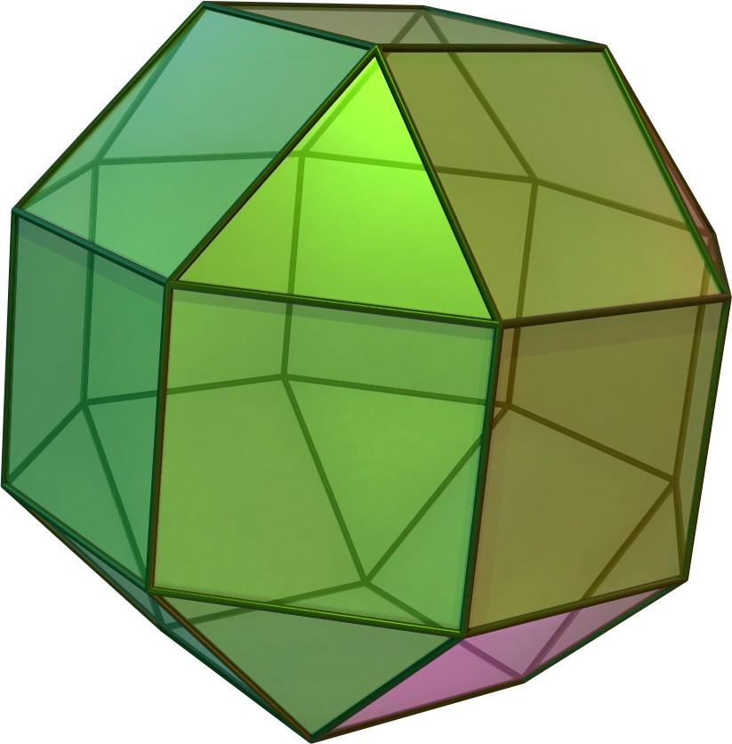

Step 2: Locate the Centers of All Faces
# Source: AI Source: Provided by: [Data Path: Persons Table -> ID Column: 1, Name_En Column: Motasem Essam] -> From: [ChatGPT] on [7/25/2026]
- Construct the center of each triangular face by drawing its medians.
- Construct the center of each square by drawing its diagonals.
- Mark the centers of all 26 faces.
- Verify that the centers are positioned consistently relative to the reference solid.
These 26 face centers become the vertices of the Deltoidal Icositetrahedron.
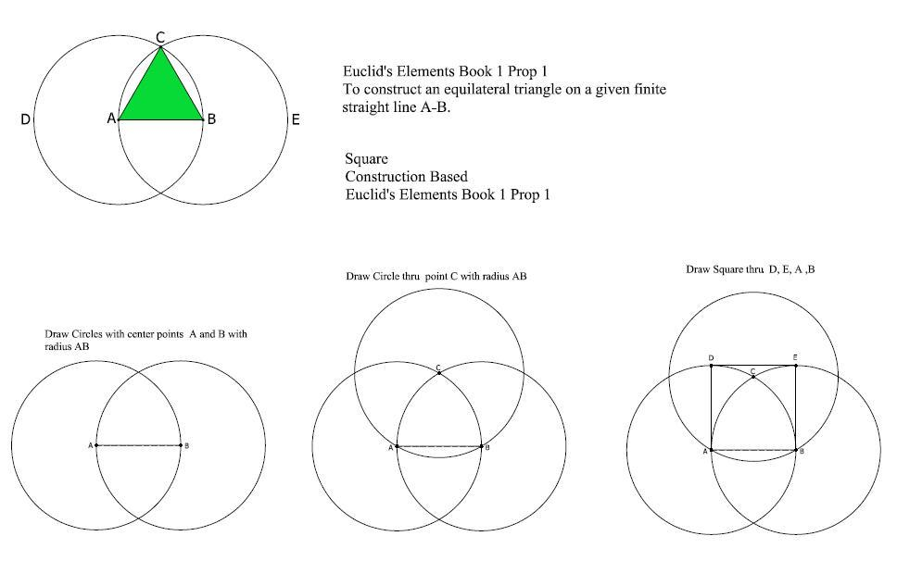

Step 3: Connect the Centers of Adjacent Faces
# Source: AI Source: Provided by: [Data Path: Persons Table -> ID Column: 1, Name_En Column: Motasem Essam] -> From: [ChatGPT] on [7/25/2026]
- Identify every pair of adjacent faces in the Rhombicuboctahedron.
- Locate the common edge shared by each pair.
- Connect the centers of the two adjacent faces using a straightedge.
- Repeat this process for all 48 edges.
- Maintain the original face-adjacency relationships.
Each connecting segment becomes an edge of the dual polyhedron.

Step 4: Construct the Kite-Shaped Faces
# Source: AI Source: Provided by: [Data Path: Persons Table -> ID Column: 1, Name_En Column: Motasem Essam] -> From: [ChatGPT] on [7/25/2026]
- Select one vertex of the Rhombicuboctahedron.
- Identify all faces surrounding that vertex.
- Locate the centers of those surrounding faces.
- Connect the centers in their cyclic adjacency order.
- Form the corresponding kite-shaped face.
- Repeat this process for all 24 vertices of the reference solid.
Each original vertex produces one kite-shaped face in the Deltoidal Icositetrahedron.

Step 5: Verify the Kite Geometry
# Source: AI Source: Provided by: [Data Path: Persons Table -> ID Column: 1, Name_En Column: Motasem Essam] -> From: [ChatGPT] on [7/25/2026]
- Confirm that all 24 quadrilateral faces are congruent.
- Verify that each face has two pairs of adjacent equal sides.
- Check that each face has three equal acute angles and one obtuse angle.
- Confirm that the short and long edges have the correct proportions.
- Verify that the faces preserve the solid's octahedral symmetry.
The approximate interior angles of each kite are:
$${81.58}^{°}, {81.58}^{°}, {81.58}^{°}, {115.26}^{°}$$

Step 6: Prepare the Kite-Shaped Faces
# Source: AI Source: Provided by: [Data Path: Persons Table -> ID Column: 1, Name_En Column: Motasem Essam] -> From: [ChatGPT] on [7/25/2026]
- Draw one accurate kite using a ruler, compass, and protractor.
- Transfer its dimensions to a geometric template.
- Reproduce the kite-shaped face 24 times.
- Mark the corresponding edge connections.
- Arrange the faces according to a verified polyhedral net.
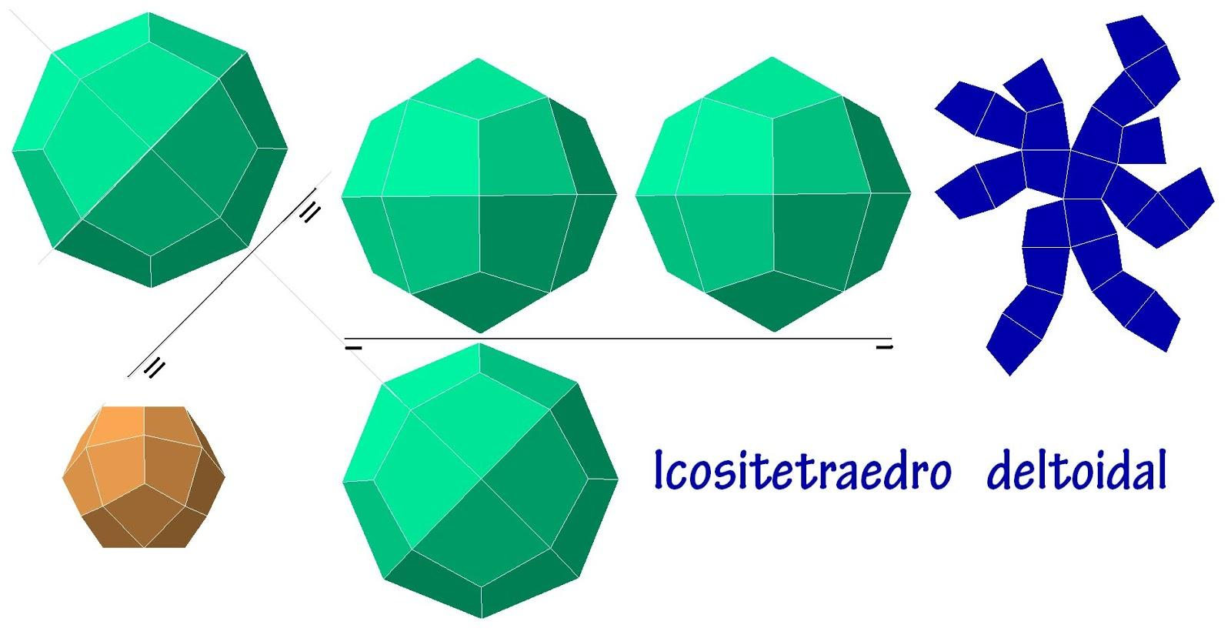

Step 7: Assemble the Three-Dimensional Solid
# Source: AI Source: Provided by: [Data Path: Persons Table -> ID Column: 1, Name_En Column: Motasem Essam] -> From: [ChatGPT] on [7/25/2026]
- Cut out the 24 kite-shaped faces.
- Fold or position the faces along their designated edges.
- Connect adjacent faces according to the verified net.
- Maintain the correct three-valent and four-valent vertex arrangements.
- Close the remaining openings.
- Inspect the completed solid to verify its convexity and symmetry.
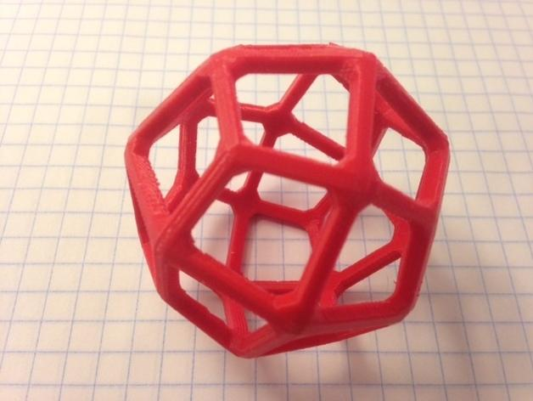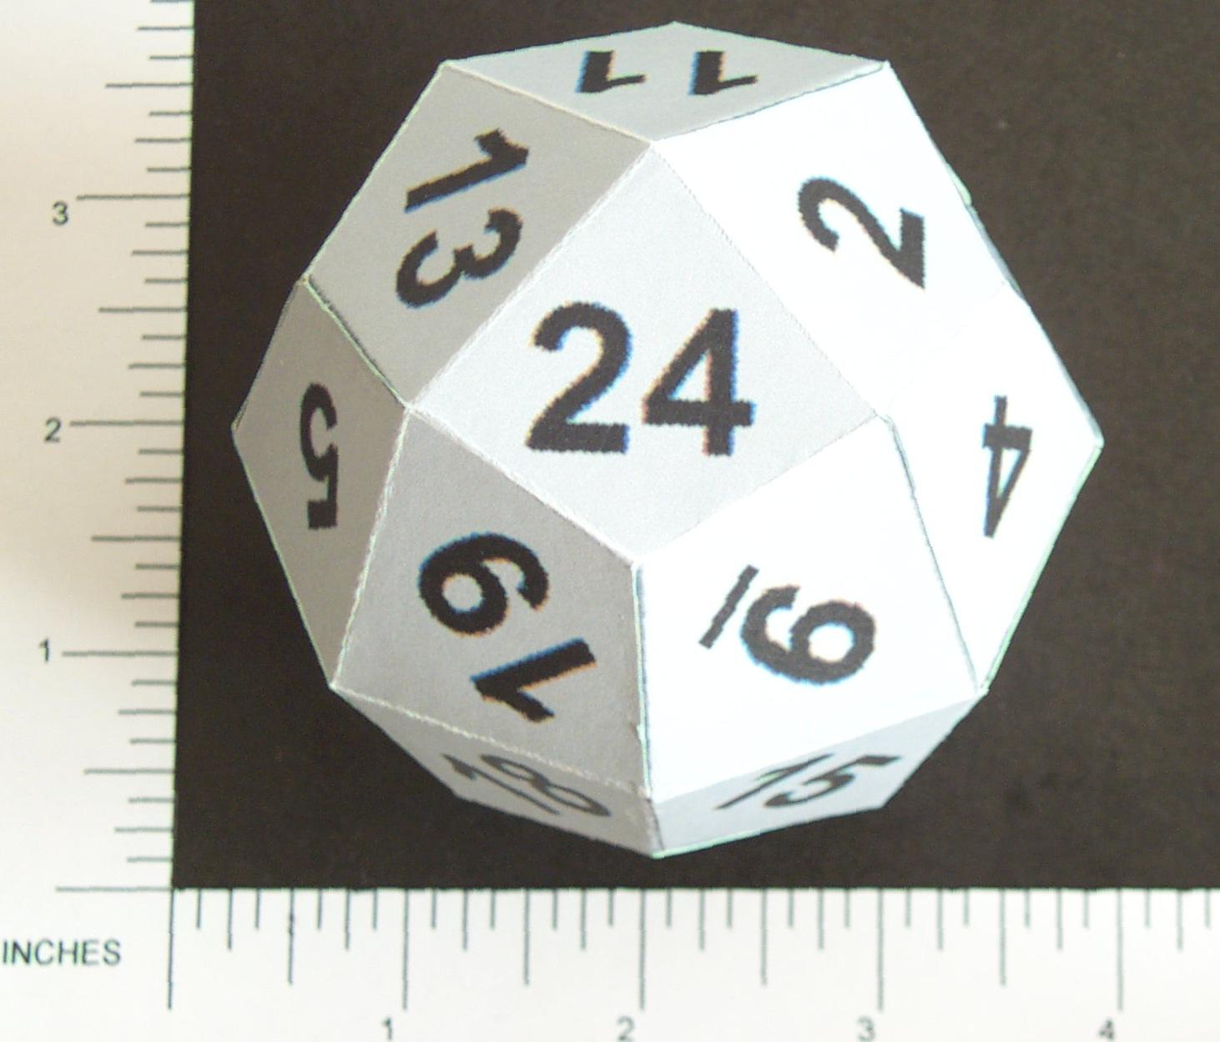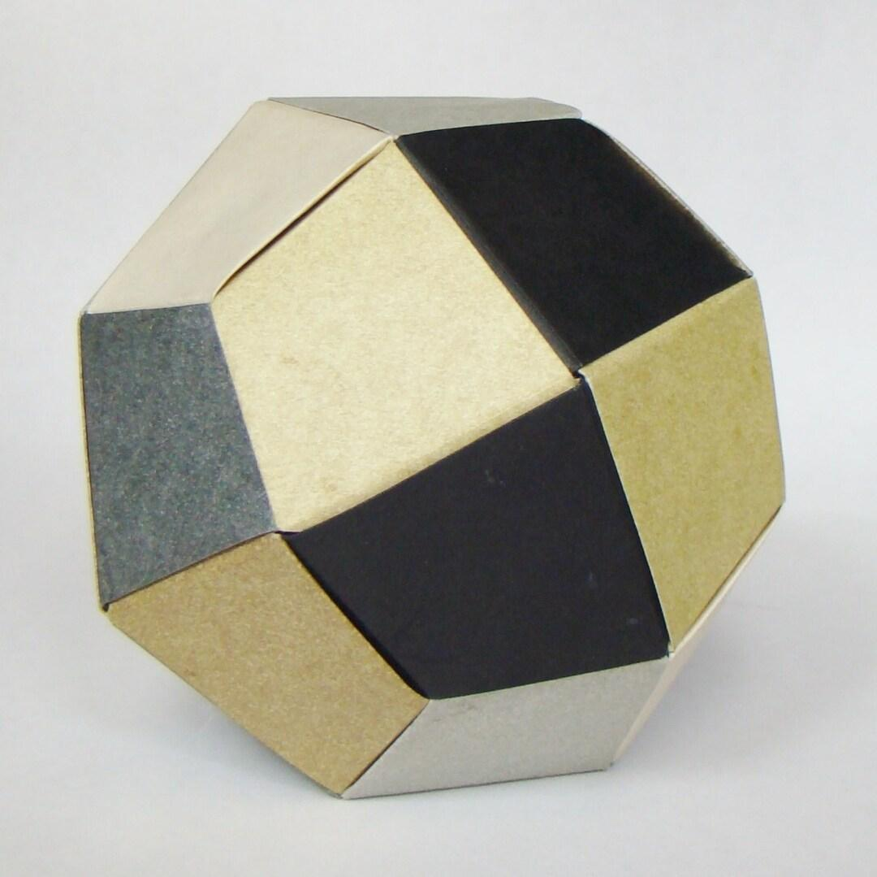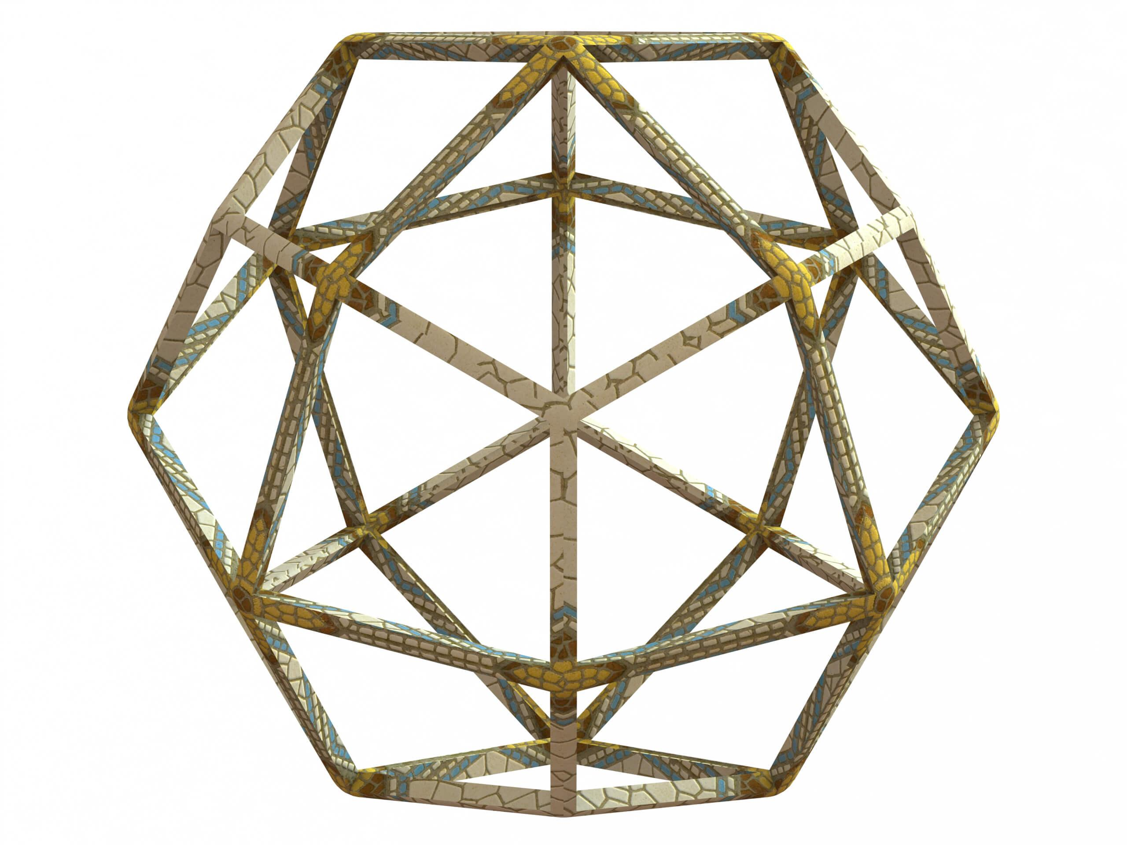

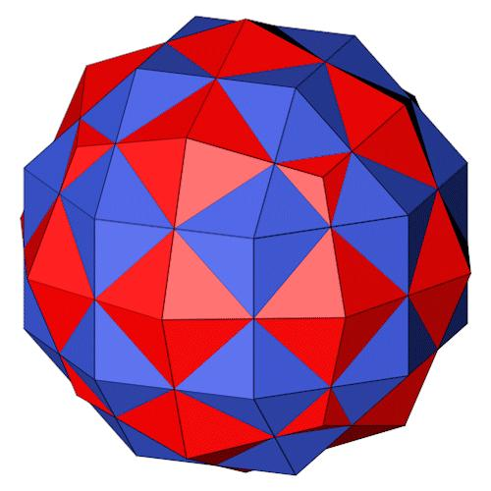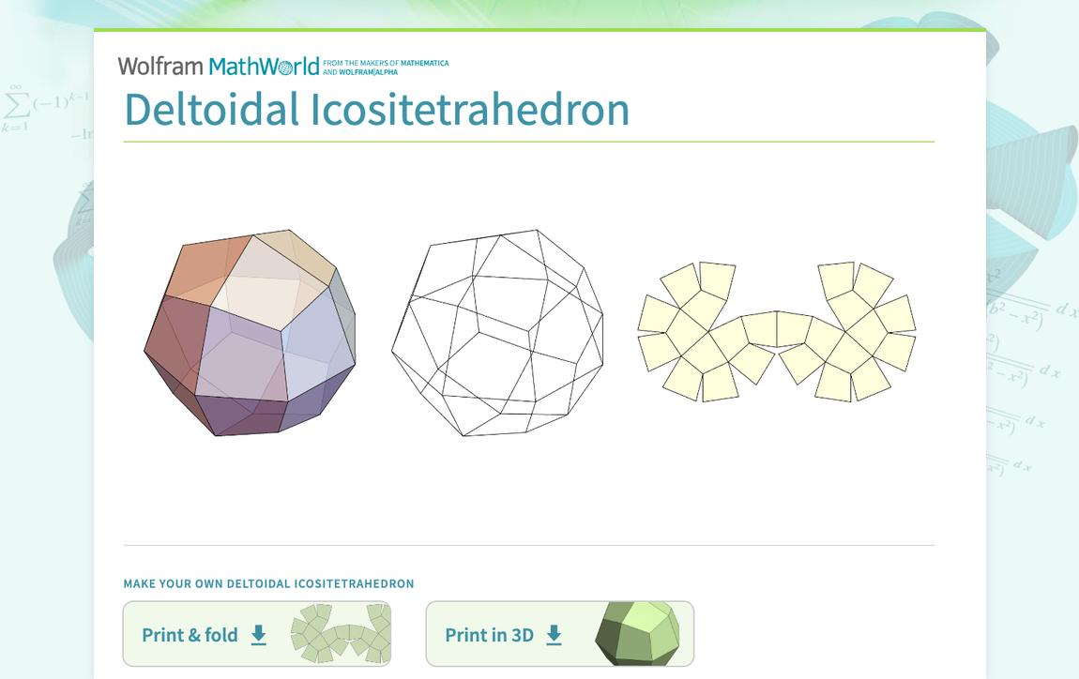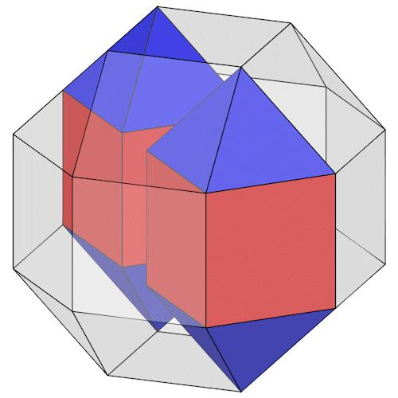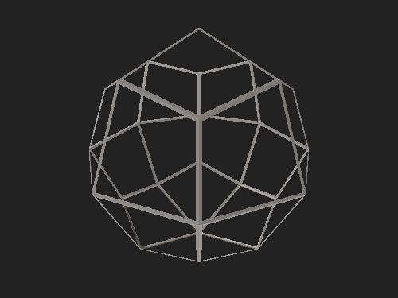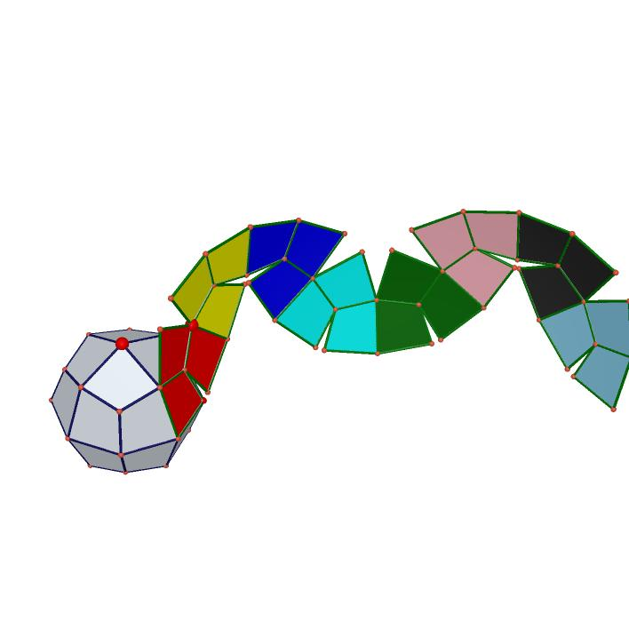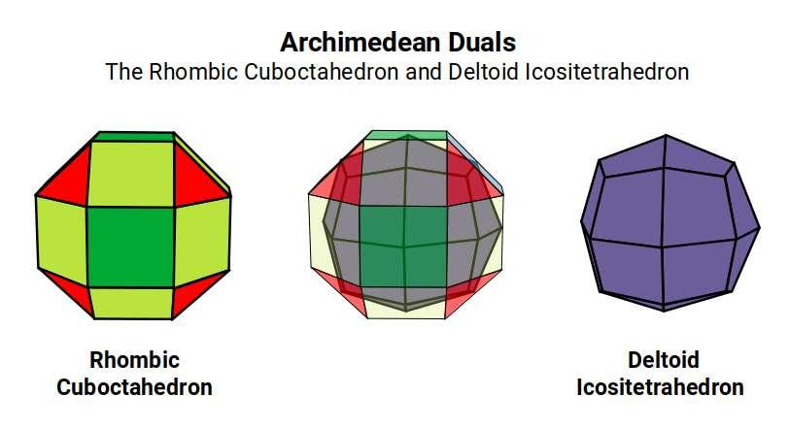

Key Points
# Source: AI Source: Provided by: [Data Path: Persons Table -> ID Column: 1, Name_En Column: Motasem Essam] -> From: [ChatGPT] on [7/25/2026]
- The Deltoidal Icositetrahedron is a Catalan solid.
- It is also called the Trapezoidal Icositetrahedron.
- It has 24 congruent kite-shaped faces.
- It has 48 edges: 24 short and 24 long.
- It has 26 vertices.
- It is convex and face-transitive.
- It has full octahedral symmetry.
- Its dual is the Rhombicuboctahedron.
- Its Euler characteristic is 2.

Conclusion
# Source: AI Source: Provided by: [Data Path: Persons Table -> ID Column: 1, Name_En Column: Motasem Essam] -> From: [ChatGPT] on [7/25/2026]
The Deltoidal Icositetrahedron is a distinctive Catalan solid characterized by 24 congruent kite-shaped faces and full octahedral symmetry. Its dual relationship with the Rhombicuboctahedron makes it an important example of duality in solid geometry and polyhedral mathematics.

